Adventure Works is a bicycle shop recently acquired by Wide World Importers. We need to merge its database to Wide World Importers’ database (WWI will be used below).

Adventure Works(AW will be used below) is the acquired company, need to integrate its database and extract useful information. So first we need to analyze WWI database.

We find the basic people’s information all include in application.people table. It concludes information like people’s full name, email address, phone number, login information and Personal Identity. WWI As the main company, we need to use its database as the main database, and merge the acquired company database according to the main database template

However, we compare people’s information in AW database. The relationship between person and other table show below

We find In the AW we can only get people’s First Name, people’s MiddleName, people’s lastname ,people’s EmailAddress, people’s phonenumber and account’s password. Other information like city’s information we can just use WWI’s tadabase.

So after analyze both two database, First, we collected the person information that we can use directly from the AW database. Create a new table to generate these information and then set the rest of information in a feasible format.

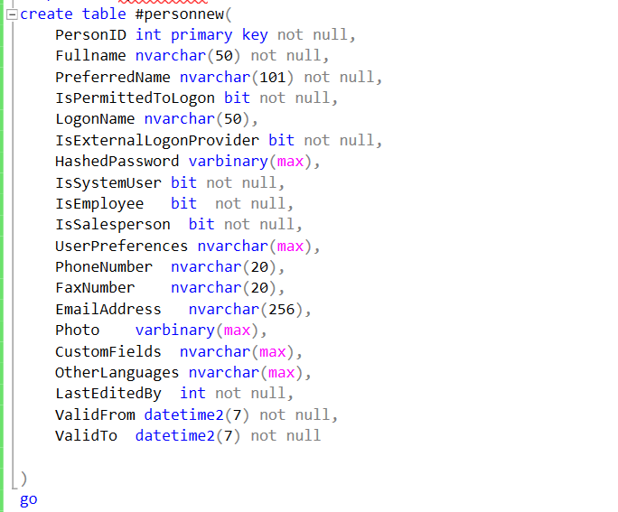

we will use AW’S passwordHash as hashpassword in WWI and after we analyzed the data stored in the WWI database logonname, we thought we could use the email address in the AW personal information as logonname. Also, for the information about preferred name we recommend that use first name as preferred name as most people do in WWI and if someone has his or her own opinion, we can rewrite the data after two database merge. For search name part we also recommend use first name + full name model as WWI do and still can rewrite after two database merges. However, AW’s database lack of authentication as a systemuser, salesperson or employee which is very important in WWI’s database. Therefore, for this part we think we need to reinsert data after we merge two databases. We also need to reset the login permit for AW’s user. And we should add user’s other language and other fields.

In order to unify the format of the two tables, we define all the people in AW as system user and last edited by 1. Using the current system time as the valid start time and using 12/31/9999 23:59:59.9999 as valid end time as WWI do. Leave photo, customerfield, UserPreferences, fax number, OtherLanguages blank to be filled in later.

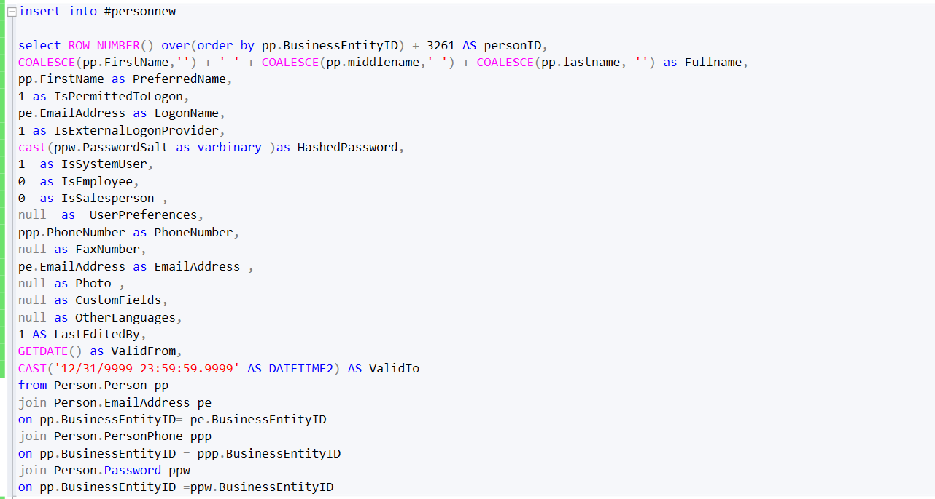

The result show below

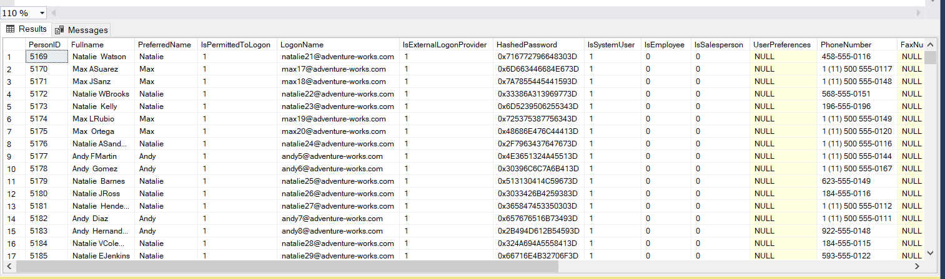

Then after wo generate people’s information and login information, we need to consider the information about product.

AW’s production information relationship is shown as below

After we compare two database the information in AW database that we can direct use will list below

Product name, product color, list price, size and modifieddate. And we can merger this information into WWI database warehouse.stockitems table. Product name can be changed into stockitemName in WWI ,modifieddate can be changed into vaildform and list price should be changed into recommendedRetailprice. We can also add vaildto column as WWI do as 9999-12-31 23:59:59.9999999 if there is no specific. And we should choose product SubcategoryID data as stockitemgroup data in WWI database. Because SubcategoryID is a group of parts and categoryID is a group of bike type. Therefore choose SubcategoryID as stockitemgroupid is much meaningful. And for supplier part, in AW purchasing.productvendor we can find the detail of supplier, so we generate the information. We set AW purchasing.productvendor’s businessEntityID as suplierID in WWI and the generate information is shown as below

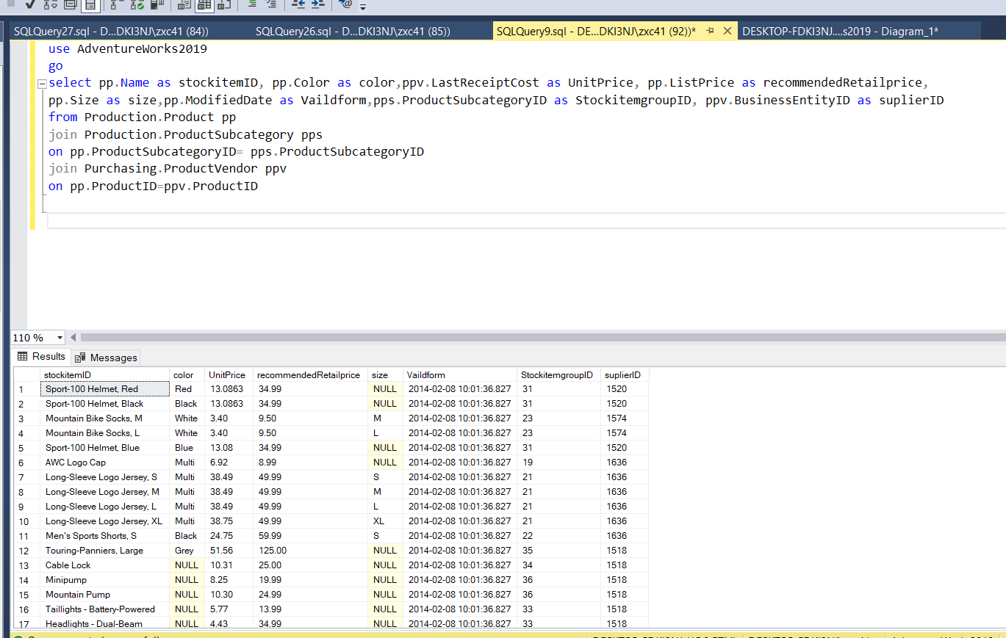

And other loss information in AW database we commend to set null or rewrite after two database merge.